CURY PARISH COUNCIL

I hereby summon you to attend a Meeting of Cury Parish Council to be held on Thursday 31 March 2022 at 7.30pm in the Cury Village Hall. The public and press are cordially invited to attend.

1. Apologies for Absence
2. Declarations of Interest – Members to declare personal and disclosable pecuniary interests (including details thereof) in respect of any item(s) on this Agenda
3. Co-Option of a New Parish Councillor
4. Chairman’s Comments
5. To agree the Minutes of the Parish Council Meeting held on Wednesday 12 January 2022
6. Matters arising from the above approved minutes which are not covered in this agenda
7. Reports
(a) To receive the Report from Cury School
(b) To receive the Report from Cornwall Councillor Anthony Soady
(c) Helston and South Kerrier Community Network Panel – Councillor S Sugrue
8. Planning
(a) To consider and respond to any Planning Applications received
(i) PA22/00911 – Mr R Lotherington - Land Rear Of Lower Tregiddle Farm Holiday Cottages, Gunwalloe Road - Formation of holiday let
(b) To receive any Planning Decisions
(i) PA21/10805 - Mr J Slade - Poledan House, Nanfant, Churchtown - Proposed detached single garage - Approved
(c) To receive any further planning correspondence
9. Parish Matters
To consider the following:-
(a) Play Equipment Proposal
(b) Playing Field
(c) Highways
(d) Public Rights of Way
(e) Public Open Spaces (Cemetery, village green, etc)
(f) Emergency Plan
10. Financial Matters
(a) To receive and approve the financial report for the previous two months
(b) To receive any LGA 1972 Section 137 Requests for grant funding
(c) Other matters
11. 100 year Commemorative Plaque presented to the PC by Kerrier District Council
12. Matters for the next Parish Council Meeting
To receive notice of items to be included on the agenda for the next Parish Council Meeting scheduled to be held on Wednesday 09 March 2022 in a location to be decided

The Council is invited to pass the following resolution “that pursuant to the Public Bodies (Admissions to Meetings) Act 1960, the press and public be excluded from the meeting for the following items of business by reason of the confidential nature of the business to be transacted”.

13. Planning Enforcement Cases

Given under my hand this Twenty Eighth day of March 2022.

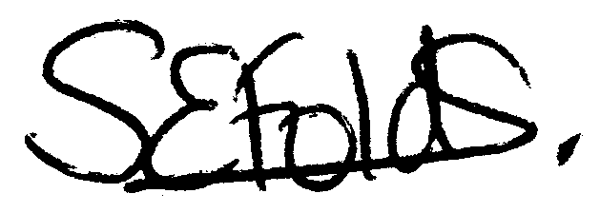

Samantha Folds - Clerk to Cury Parish Council

