CURY PARISH COUNCIL

I hereby summon you to attend a Meeting of Cury Parish Council to be held on Wednesday 10 November 2021 at 7.30pm in the Cury Methodist Chapel, Cury. The public and press are cordially invited to attend.

1. Apologies for Absence
2. Declarations of Interest – Members to declare personal and disclosable pecuniary interests (including details thereof) in respect of any item(s) on this Agenda
3. Chairman’s Comments
4. To agree the Minutes of the Parish Council Meeting held on Wednesday 08 September 2021
5. Matters arising from the above approved minutes which are not covered in this agenda
6. Reports
(a) To receive the Report from Cury School
(b) To receive the Report from Cornwall Councillor Anthony Soady
(c) Helston and South Kerrier Community Network Panel – Councillor S Sugrue
7. Planning
(a) To consider and respond to any Planning Applications received
(i) PA21/08066 - Mr Richard Nathan - Land And Buildings West Of Bonython Farmhouse, Bonython Estate - Proposed conversion of redundant barns and farmyard to holiday cottages and events venue
(b) To receive any Planning Decisions
(i) PA21/06704 - Mr R Curnow - Nanfan Farm, Churchtown - Extension to Existing Agricultural Building – Approved
(ii) PA21/06872 - Mr V Williams - Parc Drea Barn, White Cross - Building of a detached double garage - Approved
(c) To receive any further planning correspondence
8. Parish Matters
To consider the following:-
(a) Play Equipment Proposal
(b) Playing Field
(c) Highways
(d) Public Rights of Way
(e) Public Open Spaces (Cemetery, village green, etc)
(f) Emergency Plan
9. Financial Matters
(a) To receive and approve the financial report for the previous two months
(b) To receive any LGA 1972 Section 137 Requests for grant funding – Village Hall
(c) Community Infrastructure Levy Payments from Cornwall Council
(d) Other matters
10. To approve the Calendar of Meetings for 2022
11. To ratify the Council’s decision to object to PA21/07481 – Development at Hospital Cross, Helston
12. Matters for the next Parish Council Meeting
To receive notice of items to be included on the agenda for the next Parish Council Meeting scheduled to be held on Wednesday 12 January 2022 in the Cury Methodist Chapel

Council to withdraw if necessary under the Public Bodies Admissions to Meetings Act 1960 Section 1, Local Government Act 1972 Section 100 Sections 2 & 3 and Local Government Act 172 Schedule 12 Section 42. Given under my hand this Second day of November 2021.

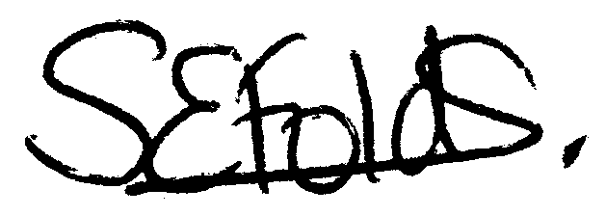

Samantha Folds - Clerk to Cury Parish Council

