CURY PARISH COUNCIL

I hereby summon you to attend a Meeting of Cury Parish Council to be held
at 7.30pm on Wednesday 08 January 2020 in the Cury Methodist Chapel, Cury.
The public and press are cordially invited to attend. Any plans are available to view from 7.15pm.

1. Apologies for Absence
2. To elect a Vice Chairman
3. Declarations of Interest – Members to declare pecuniary and non-pecuniary interests (including details thereof) in respect of any item(s) on this Agenda
4. Chairman’s Comments
- To agree the Minutes of the Parish Council Meeting held on Wednesday 13 November 2019
6. Matters arising from the above approved minutes which are not covered in this agenda
7. Reports
(a) To receive the Report from Cury School
(b) To receive the Report from Cornwall Councillor Julian Rand
(c) Helston and South Kerrier Community Network Panel

8. Planning
(a) To consider and respond to any Planning Applications received
(b) To receive any Planning Decisions
(i) PA19/08364 - Mrs West - Chez L'ouest - Variation of condition 4 in relation to Application Reference No. PA18/05313 dated 21.09.2018 for Proposed New Dwelling with integrated annexe and retention of temporary caravan during building works to allow the caravan to be retained for a further 12 months – Refused
(ii) PA19/03775 – Nanfan Farm, Churchtown, Cury – Mr J Slade – Appeal Allowed
(c) To receive any further planning correspondence

9. Parish Matters
To consider the following:-
(a) Playing Field – fruit trees
(b) Highways
(c) Public Rights of Way
(d) Public Open Spaces (Cemetery, village green, etc) – granite stone
(e) Emergency Plan
(f) Speed Limits
10. Vacancy on the Parish Council
11. To discuss the Precept Demand for 2020/21
12. Financial Matters
(a) To receive and approve the financial report for the previous two months
(b) To receive any LGA 1972 Section 137 Requests for grant funding
(c) Other matters
13. Correspondence
14. Matters for the next Parish Council Meeting
To receive notice of items to be included on the agenda for the next Parish Council Meeting scheduled to be held on Wednesday 11 March 2020 in the Cury Methodist Chapel

Council to withdraw if necessary under the Public Bodies Admissions to Meetings Act 1960 Section 1, Local Government Act 1972 Section 100 Sections 2 & 3 and Local Government Act 172 Schedule 12 Section 42. Given under my hand this 2nd day of January 2020.

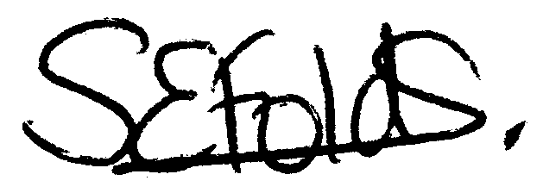

Samantha Folds - Clerk to Cury Parish Council

