CURY PARISH COUNCIL MEETING

Wednesday 11 November 2015

Report compiled by PCSO Berry 1000 hrs on Friday 6 November.

Please accept my apologies for not attending the meeting this evening.

During September and October there was a theft of heating oil reported to the police. This crime has been filed pending further information coming forward.

I am pleased to advise you that Halloween passed without any reports of antisocial behaviour across the whole of the Helston Sector. We would like to thank everyone for their consideration for other people.

If you have any crimes you would like to report please telephone 101, or should you have any concerns which you would like to discuss please call me on 01326 555158, this is an answer machine service, please leave a message and I will get back to you. Alternatively, email Helston@devonandcornwall.pnn.police.uk

PC14940 Anne Butcher
PCSO 30053 Julia Berry
SC Chris Butterill
SC Tony Soady

Helston Police Station
Cornwall and Isles of Scilly Basic Command Unit
Godolphin Road Helston Cornwall TR13 8QE

Emergency calls 999
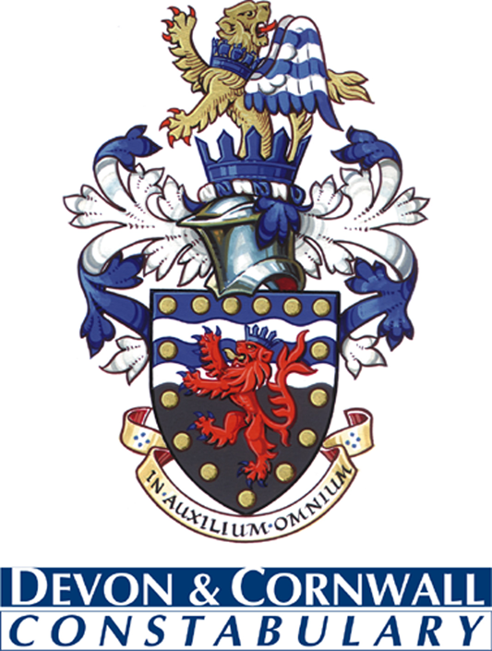Non-urgent calls 101
Crimestoppers 0800 555 111
Helston@devonandcornwall.pnn.police.uk
www.devon-cornwall.police.uk
Building safer communities together

