CURY PARISH COUNCIL

I hereby summon you to attend a Meeting of Cury Parish Council to be held immediately following the Annual Meeting of Cury on Thursday 25 May 2023 in the Cury Village Hall, Cury. The public and press are cordially invited to attend.

1. Apologies for Absence
2. Declarations of Interest – Members to declare personal and prejudicial interests (including details thereof) in respect of any item(s) on this Agenda
3. Chairman’s Comments
- To agree the Minutes of the Parish Council Meeting held Thursday 23 March 2023
5. Matters arising from the above approved minutes which are not covered in this agenda
6. Reports
(a) To receive an update on Cury School
(b) To receive the Report from Cornwall Councillor Anthony Soady
(c) Helston and South Kerrier Community Area Partnership – appoint representative
7. Planning
(a) To consider and respond to any Planning Applications received
(i) PA23/02208 - Mr & Mrs Palmer - Sunny Corner, White Cross - Loft conversion and balcony area
(b) To receive any Planning Decisions
(i) PA23/01821 - Pol Glas Cabin, Nanfant - Addition of Solar Panels to Existing Building – Approved
(ii) PA23/00571 - - Trouble My Wits, Cury - The erection of a 12 metre x 6 metre residential timber building on a prepared concrete base, and associated works – Refused
(iii) PA23/01395 – Franchis Holiday Park, Bochym Hill – Proposed siting of 1 static home - Approved
(c) To receive any further planning correspondence
8. Parish Matters
To consider the following:-
(a) Playing Field
(b) Highways
(c) Public Rights of Way
(d) Public Open Spaces (Cemetery, village green, etc)
(e) Emergency Plan
9. To approve the Annual Insurance Renewal
10. To subscribe to Cornwall Association of Local Councils for 2023/24
11. Financial Matters
(a) Annual Accounts to Year End 31 March 2023
i) To complete the Annual Governance Statement for the Year Ending 31 March 2023
ii) To receive and approve the internally audited accounts for the Year Ending 31 March 2023
iii)To appoint an Internal Auditor for 2023-24
(b) To receive and approve the financial report for the previous two months
(c) To receive any LGA 1972 Section 137 Requests for grant funding
(d) Other matters
12. Correspondence
13. Matters for the next Parish Council Meeting
To receive notice of items to be included on the agenda for the next Parish Council Meeting scheduled to be held on Thursday 27 July 2023 in the Cury Village Hall

Council to withdraw if necessary under the Public Bodies Admissions to Meetings Act 1960 Section 1, Local Government Act 1972 Section 100 Sections 2 & 3 and Local Government Act 172 Schedule 12 Section 42. Given under my hand this Seventeenth day of May 2023.

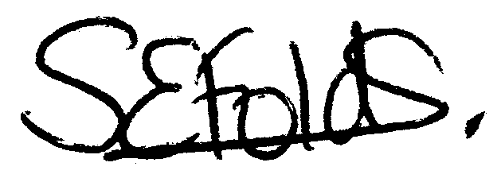

Samantha Folds
Clerk to Cury Parish Council

