CURY PARISH COUNCIL

I hereby summon you to attend a Meeting of Cury Parish Council to be held on Thursday 23 November 2023 at 7.00pm in the Cury Village Hall, Cury. The public and press are cordially invited to attend.

1. Apologies for Absence
2. Declarations of Interest – Members to declare personal and prejudicial interests (including details thereof) in respect of any item(s) on this Agenda
3. Chairman’s Comments
- To agree the Minutes of the Parish Council Meeting held on Thursday 28 September 2023
5. Matters arising from the above approved minutes which are not covered in this agenda
6. Reports
(a) To receive an update on Cury School
(b) To receive the Report from Cornwall Councillor
(c) Helston and South Kerrier Community Area Partnership
7. Planning
(a) To consider and respond to any Planning Applications received
(b) To receive any Planning Decisions
(i) PA23/06737 - Mr J Trounson - Land South East Of Colvennor Farm - General Purpose Agricultural Shed – Approved
(ii) PA23/04911 – Mr J Trounson - Proposed change of use from agricultural shed to residential dwelling, including associated landscaping and external works - Agricultural Shed At Colvennor Farm Colvennor - Approved
(c) Any correspondence received
8. Parish Matters
To consider the following:-
(a) Playing Field
(b) Highways
(c) Public Rights of Way
(d) Public Open Spaces (Cemetery, village green, etc)
(e) Emergency Plan
9. To discuss the purchase and erection of a ‘Parish Council Meeting this Thursday’ sign
10. To approve the Calendar of Meetings 2024
11. Financial Matters
(a) To discuss the Precept Demand for 2024/25
(b) To receive and approve the financial report for the previous two months
(c) To receive any LGA 1972 Section 137 Requests for grant funding
(d) Other matters
12. Correspondence
13. Matters for the next Parish Council Meeting
To receive notice of items to be included on the agenda for the next Parish Council Meeting scheduled to be held on Thursday 23 November 2023 in the Cury Village Hall

Council to withdraw if necessary under the Public Bodies Admissions to Meetings Act 1960 Section 1, Local Government Act 1972 Section 100 Sections 2 & 3 and Local Government Act 172 Schedule 12 Section 42. Given under my hand this Fourteenth day of November 2023.

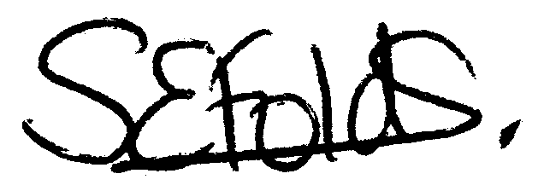

Samantha Folds
Clerk to Cury Parish Council

