CURY PARISH COUNCIL

I hereby summon you to attend a Meeting of Cury Parish Council to be held
at 7.30pm on Wednesday 11 March 2020 in the Cury Methodist Chapel, Cury.
The public and press are cordially invited to attend. Any plans are available to view from 7.15pm.

1. Apologies for Absence
2. To Co-opt two members onto the Parish Council
3. Declarations of Interest – Members to declare pecuniary and non-pecuniary interests (including details thereof) in respect of any item(s) on this Agenda
4. Chairman’s Comments
- To agree the Minutes of the Parish Council Meeting held on Wednesday 08 January 2020
6. Matters arising from the above approved minutes which are not covered in this agenda
7. Reports
(a) To receive the Report from Cury School
(b) To receive the Report from Cornwall Councillor Julian Rand
(c) Helston and South Kerrier Community Network Panel – Councillor S Sugrue
- Dark Skies report – Councillor Miss P Oates
- Village Hall Centenary – Councillor Miss P Oates

8. Planning
(a) To consider and respond to any Planning Applications received
(i) PA20/01176 - Mr Martin Caton - Bochym Manor, Bochym - Replace existing inappropriate conservatory superstructure with new painted timber superstructure, with powder coated roof glazing covers
(ii) PA20/01177 - Mr Martin Caton - Bochym Manor, Bochym - Replace existing inappropriate conservatory superstructure with new painted timber superstructure, with powder coated roof glazing covers
(iii) PA20/01260 - Mr J Slade - The Cabin, Nanfan, Churchtown - Retrospective consent for the conversion of games room building into a holiday-let
(b) To receive any Planning Decisions
(i) PA19/05033 - Mrs C Jenkins - Penvearne Cottage, Cury Cross Lanes - Proposed Restoration and Reinstatement of the Store to Living Accommodation and Internal alterations – Approved
(ii) PA19/05034 - Mrs C Jenkins - Penvearne Cottage, Cury Cross Lanes - Listed building consent sought for the proposed restoration and reinstatement of the store to living accommodation and internal alterations - Approved
(c) To receive any further planning correspondence

9. Parish Matters
To consider the following:-
(a) Playing Field – fruit trees
(b) Highways
(c) Public Rights of Way – Local Maintenance Partnership Offer 2020/21
(d) Public Open Spaces (Cemetery, village green, etc) – granite stone
(e) Emergency Plan
(f) Speed Limits

10. Financial Matters
(a) To receive and approve the financial report for the previous two months
(b) To receive any LGA 1972 Section 137 Requests for grant funding
(c) Other matters

11. Correspondence
12. Matters for the next Parish Council Meeting
To receive notice of items to be included on the agenda for the next Parish Council Meeting scheduled to be held on Wednesday 13 May 2020 in the Cury Methodist Chapel

Council to withdraw if necessary under the Public Bodies Admissions to Meetings Act 1960 Section 1, Local Government Act 1972 Section 100 Sections 2 & 3 and Local Government Act 172 Schedule 12 Section 42. Given under my hand this 3rd day of March 2020.

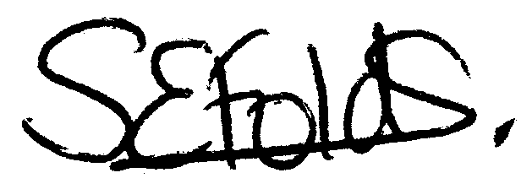 Samantha Folds - Clerk to Cury Parish Council

