CURY PARISH COUNCIL

I hereby summon you to attend an Extraordinary Meeting of Cury Parish Council to be held at 7.30pm on Monday 12 February 2018 in the Cury Methodist Chapel, Cury. The public and press are cordially invited to attend. Any plans are available to view from 7.25pm.

1. Apologies for Absence

2. Declarations of Interest – Members to declare personal and prejudicial interests (including details thereof) in respect of any item(s) on this Agenda

3. To agree the Minutes of the Parish Council Meeting held on Wednesday 10 January 2018

4. To consider and respond to the following Planning Application:-

PA18/00294 – The Bonython Estate – Post Office, Cury Cross Lanes – Advertisement consent for display on 1 no. Illuminated fascia and 1 no. Illuminated hanging sign

5. To discuss The Boundary Commission’s Electoral Review for Cornwall

Council to withdraw if necessary under the Public Bodies Admissions to Meetings Act 1960 Section 1, Local Government Act 1972 Section 100 Sections 2 & 3 and Local Government Act 172 Schedule 12 Section 42. Given under my hand this Sixth day of February 2018.

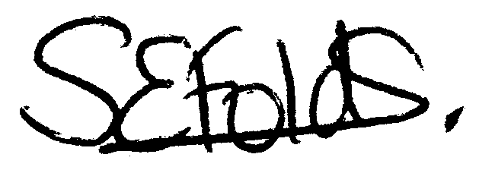

Samantha Folds
Clerk to Cury Parish Council

